Chapter 18, Solution 51.

In the frequency domain, the voltage across the 2-Ω resistor is
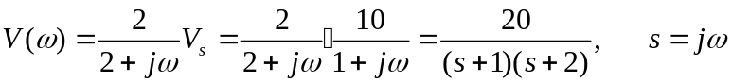
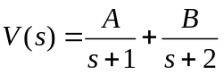

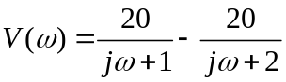
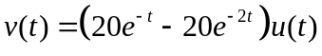
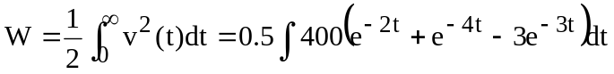
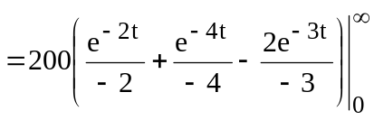= 16.667 J.

